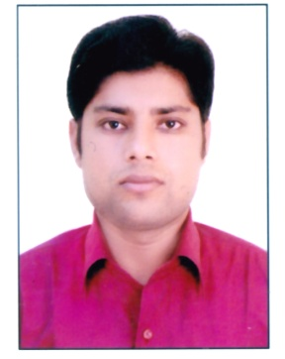
Curriculum Vitae

MD MODASSAR ALAM

Address : H.NO. 4/33 NEW ABADI BHAMOLA ALIGARH
Phone : +918791550053 ,+918938988817
E.Mail : modassaralam92@gmail.com
Date of Birth : 15-01-1992
Area of Interest : civil site engineer , Quality Control and land survey

Career Objective

Seeking for a challenging position as a Civil Engineer, where I can use my planning, designing and overseeing skills in construction and help to the grow the company to achieve its goal.
Academic Qualifications

Course (Stream)/Examination | Institution/University | Month/ Year of Passing | Performance
B.Tech IN  CIVIL | MANGALAYATAN UNIVERSITY  ALIGARH | 2016 | 66.38%
SENIOR SECONDARY | National institute of open schooling | 2011 | 59%
HIGH SCHOOL | Patna | 2006-07 | 63%

Work Experience
- Company Name :- Facula real estate Pvt. Ltd.
Project :- Residential Building
Address :- Wahid Nagar,Radio Colony Aligarh ,U.P.
Department :- Civil Engineer
Job Title :- Site Civil Engineer and Quality Control
From :- 03th feb 2016 to 10th Feb 2017
- Company :- Feedpro Hatcheries & farms Pvt. Ltd
Project :- Poultry & Hatcheries Farm Industries
Address :- Khasra 37 Rooppur Road, Vill. Sujanpur, Near
Shri Shyam Dhaba, Teshil Khair, Distt. Aligarh
Department :- Civil Engineering
Job Title :- Site Civil Engineer
From :- 15th May, 2017 to till now

Summer Internship

Name of Company :- PWD, ALIGARH UP
Project :- Road Construction
Field :- Site Engineer & Quality Control.
Study for check out :- How to construct road and I also observe the Quality
Control
From :- 25 June 2015 to 05 August 2015

Academic Project

- Project on Residential Building

Technical Qualification
- Land survey with the help of TOTAL STATION
- Bar Bending Schedule
- Cost and Estimate
IT Skills
- MS Office
- AUTO CAD
- Revit Architect
Hobbies
- Listening music & Watching hollywood movies
- Internet Surfing .
- Riding bikes .
Language
- Hindi
- English
- Urdu .
Declaration

I hereby declare that all the details furnished above are true to the best of my knowledge.

Date:
Place:
(MD MODASSAR ALAM)

